Technical material specifications – Need to knows
As we strongly believe that you as the customer are looking for a durable product that will add value to your property, we bring to your attention that our prices quoted are based on the following:
Concerning carports, we quote as a rule on the option that we see as best suited for the project in question than on the cheapest option but the final decision rest with you the customer and your needs.
We will thus in conjunction with you discuss the necessary.
• We use 2mm minimum thickness steel and not 1.6mm as do most of our opposition.
• If thinner steel is used, it cannot as per SABS standards support the same span. Where the span is in excess of an expectable standard, we will place and weld two profile sections together “boxed”. With even greater span applications, we will make up rafters of say angle iron to compensate instead of just using a cold formed lip channel section.
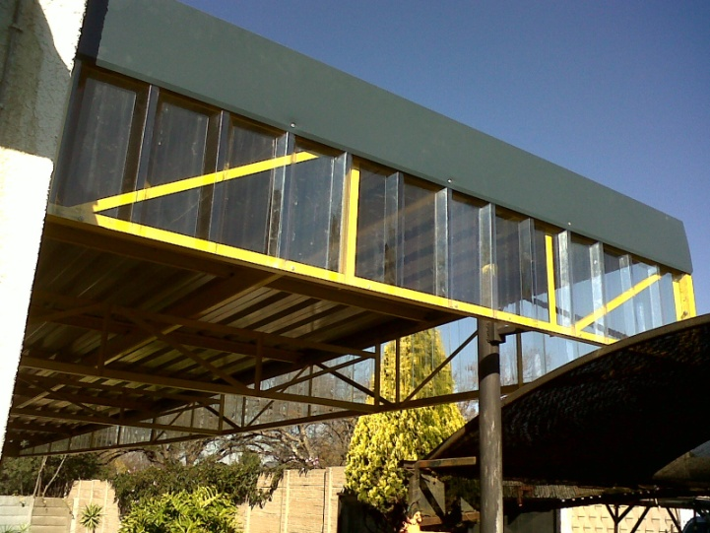
• Sheeting used is 0.5mm thick (0.1mm difference in thickness, example 0.4mm thick sheeting do not have the same load carrying capacity as 0.5mm sheeting) If thinner sheeting is used, then the rafter spacing should be closer to adhere to expectable standards.
• Galvanised coatings are specified in a wide range of coating mass categories. The galvanising specification of the sheeting we use is to Z275 and not to Z175. This determines the resistance to rust and subsequently the product life. The Z prefix in the coating designation indicates the zinc coating while the number denotes the total mass of the zinc coating deposited to both the top and bottom surfaces of the sheet in grams per square meter (g/m²).
• We recommend that pre-painted sheeting be used. CHROMADEK® is Mittal Steel South Africa’s trade name for a range of colour coated sheet products. It is produced by coating sheet on a sophisticated coil coating line, where steel substrate surfaces are thoroughly chemically cleaned before a primer coat is applied to either one or both sides of the sheet. After elevated temperature curing, the top coat is applied, to either one or both sides and again cured in the gas fired furnaces.
ISCOR CHROMADEK ® |  | ISCOR CHROMADEK ® |  | BHP COLORBOND ®
DARK DOLPHIN |  | TABLE BAY |  | COLONIAL GREEN
BUFFALO BROWN |  | BATELEUR BROWN |  | ATTOL GREEN
KINGFISHER BLUE |  | UMHLANGA WAVE |  | RIVERGUM
FISH EAGLE WHITE |  | OKAVANGO SUNSET |  | AFRICAN BLUE
GEMSBOK SAND |  | TRAFFIC GREEN |  | AFRICAN CREAM
KNYSNA WILDERNESS |  | SANDSTONE BEIGE |  | SILVER WHITE
 |  |  |  | CAPE WHITE
PLEASE NOTE:
Colours are approximate only

Over and above its aesthetic attributes, CHROMADEK® paint coatings are designed to provide superior corrosion protection under conditions where the performance of unpainted galvanised sheeting may prove inadequate. Chromadek is applied onto a galvanised coated substrate, which has been produced by the addition of Antimony and Aluminium to the molten zinc in the bath, to improve the formability and adherence of the zinc coating. Excellent paint adhesion is achieved and corrosion resistance enhanced by careful preparation of the steel surface prior to paint application. Standard CHROMADEK® is intended for use under rural, mildly chemically pollutedor moderate marine conditions, and is composed of Z275 hot-dip galvanised substrate pre-primed with an epoxy/chrome-free primer (dry film thickness (DFT) of 4-6 microns) and finished with a final paint coat (DFT 18-22 microns) on the top surface. A single backing coat (DFT 8 microns) is normally applied to the reverse side of the sheet.
• If you project involve the use of polycarbonate sheeting, we will use 1.2mm thick sheeting in this instance.
• We do not use existing and second-hand steel and sheeting but only new material.
We believe that as the customer, it is in your best interest to consider the above when evaluating your project. For a more in-depth approach to, material specifications visit our web-site at http://www.ap-carportsandfencing.co.za Also, go to the testimonial page to see what our existing customers have to say about as.
The AP Carports and Fencing PTY Ltd. team aim to build long-term relationships based on quality and customer satisfaction.
Thank you for your support

